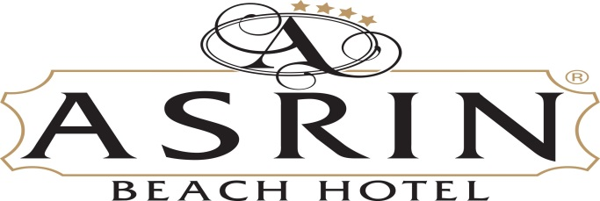

**ASRIN BEACH HOTEL SUMMER 2024 FACTSHEET**

**ADREES:** : İNCEKUM MEVKİİ 07490 TÜRKLER ALANYA/ANTALYA

**PHONE:** : +90 242 534 11 80

**FAX:** : +90 242 534 11 80

**CATEGORY:** : 4*

**OPENED:** : 1997

**LAST RENOVATION** :2018(partialrenovation)

**BOARD:** : ALL INCLUSIVE PLUS

**WEBSITE:** : www.asrinbeachhotel.com

**E-MAIL** : asrinbeachhotel@asrinbeachhotel.com

**LOCATION**

Itsconnectedtotheseawithourundergraundway. Inourfacilitywehave 80 metres-longbeach. Thedestiniesareto Antalya airport 100km, to Gazipaşa airport 55km, to Konaklı 5km. Our hotel formed on 9.000m2 fieldandcomprise of totaly 250 roomsand 500 bed. Our hotel comprise of 6 floorsandone main building.

**ROOMS**

Thereare 250 roomstotaly. 189 of theroomsare standart for 3 personand 61 of themare standart for 2 personalso. 2 of 61 roomsarehandicaproom.

* **STANDART ROOM**

Inroomthere is onebedfor 2 person, andthere is onebedforsınglepersonalso. There is alsobath-tube/toiletandshower/hairdryer/telephone/splitaircondition/tv/musıcchannels/safeforrent (charge )minibar/balcony/graund of theroomsareceramic.

**ALL INCLUSIVE**

Allinclusiveconcept is between 10:00 and 23:00. Allnativealcoholicandnon-alcoholicand hot drinks (tea-coffe,etc) areincludingallinclusiveconcept.

**FOOD AND BEVERAGE**

**MAIN RESTAURANT**

Breakfast, latebreakfast,luch,dinnerareservingwithopenbuffetsystem. Close part of ourrestaurantfor 400 person, openpartfor 100 persons. Capacity is 500 personstotaly.

**BARS**

Wehave 4 bar in our hotel. Thesearepool bar, beach bar, restaurant bar andlobby bar.

**POOLS**

Wehave 3 pools. Theseareslidepool, main poolandchildpool. At thepoolandbeachsunbed, umbrellaarefree of charge. Beach towelsareprovidingwithdepositfromthereception.

**BEACH**

Ourbeachis well-keptandclean. Beach is comprise of sandandpebble. Transportationtothebeach is beingsuppliedbyundergroundway. Wehaveserve of drinkandfoods at snack bar between10:00and 18:00 o’clock.

**ACTIVITIES**

* **ANIMATION**

Ouranimationteam can speakTurkısh, Englısh, Deutch and Russian. Wehavesoftanimationactivitiesallday. Ifthereareenoughtguests step, aerobik,tabletennis, beachvolleyballandboçça. Once a weekTurkishnight.

Mini clubandchildrenplaygraund. Wehavekidanimationalso. Forthe mini clubtheagebetween 4 – 12.

**TURKISHBATH AND SAUNA**

Turkishbath and Sauna ,Massage , pouchfoamandotherthingsarewith a charge.

**CHARGE ACTIVITIES**

Internet(wi-fi),Therentsafe in theroom, doctor, rent a car, market, photo, watersports(privatecompany) andotherstoresareservingwithprice. Freshfruitjuices, Turkishcoffeandbottleddrinksarewithcharge.

**OTHER AKTIVITIES**

* Weare not acceptingpets.
* Wehavetwopanoromiclifts.
* Weare not servinganyalcoholicdrinkstounderage 18.
* Check-in time 14:00, Check-out time 12:00.